SIMATS ENGINEERING
ASSESSMENT TOOL II – DATA ANALYSIS PROJECT
Course: Data Handling and Visualization | Code: DSA0601 | CO: CO3
Duration: 120 min | Total Marks: 100 | Reg No : 192424403  Name: Prithika BH

COURSE OUTCOME COVERED
CO3: Analyze time-series data, trends, associations, and uncertainty through appropriate visualization methods. (BL4)
Activity Tool : Data Analysis Project
Weightage: 20%

Code of Conduct:
I Prithika BH(192424403) (Name / Reg No) certify that this submission is my original work and that I have adhered to the guidelines specified for this assessment. I understand that any violation of academic integrity rules will result in disciplinary action.
Signature of the student:
Criteria | Problem  Understandin g  & Data  Preparation  25% | Data Analysis &  Interpretation 30% | Application  of Analytical Techniques  20% | Analysis  of Results 15% | Organization &  Documentati on  10% | Presentati on &  Clarity  5% | Total
Q1
Q2
Q3
Q4
Q5

Data Analysis Project
Question 1 – Distribution Analysis Using ECDF and Q-Q Plot
Dataset: Employee_Salaries.csv
Assessment Task
Using the Employee_Salaries dataset, analyze the distribution of employee salaries.
1. Create an empirical cumulative distribution function (ECDF) for Salary.
2. Create a Q-Q plot to assess whether Salary is approximately normally distributed. 3. Compare the salary distributions of the four departments using suitable distribution plots. 4. Identify any possible skewness or unusual observations and explain what the plots reveal.
Dataset:
Employee_ID | Department | Salary
E001 | IT | 42000
E002 | IT | 45000
E003 | IT | 48000
E004 | IT | 51000
E005 | IT | 55000
E006 | HR | 38000
E007 | HR | 40000
E008 | HR | 42000
E009 | HR | 46000
E010 | HR | 50000
E011 | Finance | 47000
E012 | Finance | 49000
E013 | Finance | 52000
E014 | Finance | 58000
E015 | Finance | 65000
E016 | Marketing | 36000
E017 | Marketing | 39000
E018 | Marketing | 43000
E019 | Marketing | 47000
E020 | Marketing | 72000

R Code:
# ============================================================
# Q1: EMPLOYEE SALARY DISTRIBUTION
# ============================================================

library(ggplot2)
library(dplyr)

# -------------------------
# 1. Create Dataset
# -------------------------

employee <- data.frame(
Employee_ID = c(
"E001","E002","E003","E004","E005",
"E006","E007","E008","E009","E010",
"E011","E012","E013","E014","E015",
"E016","E017","E018","E019","E020"
),

Department = c(
rep("IT",5),
rep("HR",5),
rep("Finance",5),
rep("Marketing",5)
),

Salary = c(
42000,45000,48000,51000,55000,
38000,40000,42000,46000,50000,
47000,49000,52000,58000,65000,
36000,39000,43000,47000,72000
)
)

# View data
print(employee)

# -------------------------
# 2. ECDF Plot
# -------------------------

ggplot(employee, aes(x = Salary)) +
stat_ecdf(geom = "step") +
labs(
title = "Empirical Cumulative Distribution Function of Employee Salaries",
x = "Salary",
y = "Cumulative Probability"
) +
theme_minimal()

# -------------------------
# 3. Q-Q Plot
# -------------------------

ggplot(employee, aes(sample = Salary)) +
stat_qq() +
stat_qq_line() +
labs(
title = "Q-Q Plot of Employee Salaries",
x = "Theoretical Quantiles",
y = "Sample Quantiles"
) +
theme_minimal()

# -------------------------
# 4. Department-wise Boxplot
# -------------------------

ggplot(employee, aes(x = Department, y = Salary, fill = Department)) +
geom_boxplot() +
labs(
title = "Salary Distribution Across Departments",
x = "Department",
y = "Salary"
) +
theme_minimal() +
theme(legend.position = "none")

# -------------------------
# 5. Department-wise Violin Plot
# -------------------------

ggplot(employee, aes(x = Department, y = Salary, fill = Department)) +
geom_violin(trim = FALSE) +
geom_boxplot(width = 0.1, fill = "white") +
labs(
title = "Salary Distribution by Department",
x = "Department",
y = "Salary"
) +
theme_minimal() +
theme(legend.position = "none")
# -------------------------
# 6. Summary Statistics
# -------------------------
salary_summary <- employee %>%
group_by(Department) %>%
summarise(
Mean = mean(Salary),
Median = median(Salary),
SD = sd(Salary),
Minimum = min(Salary),
Maximum = max(Salary),
Range = max(Salary) - min(Salary)
)

print(salary_summary)

# Overall statistics
cat("Overall Mean Salary:", mean(employee$Salary), "\n")
cat("Overall Median Salary:", median(employee$Salary), "\n")
cat("Overall SD:", sd(employee$Salary), "\n")

Answers:
- Create an empirical cumulative distribution function (ECDF) for Salary.
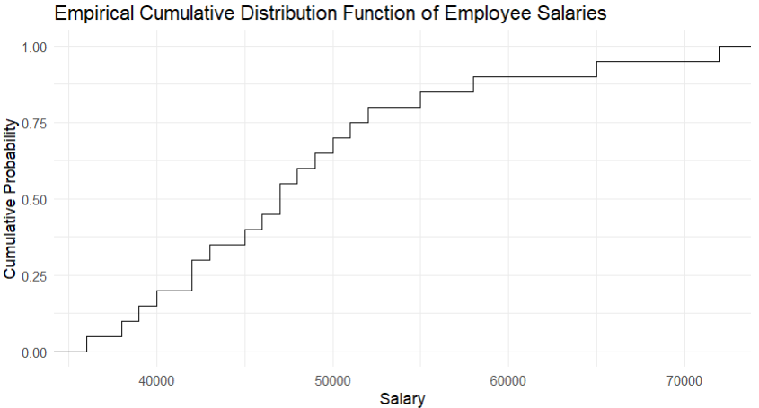
- Create a Q-Q plot to assess whether Salary is approximately normally distributed.
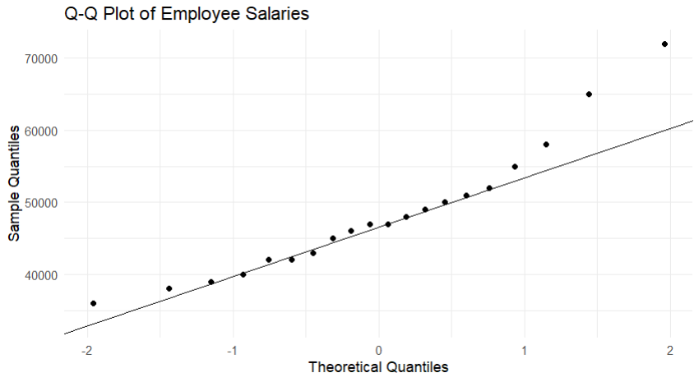
- Compare the salary distributions of the four departments using suitable distribution plots.
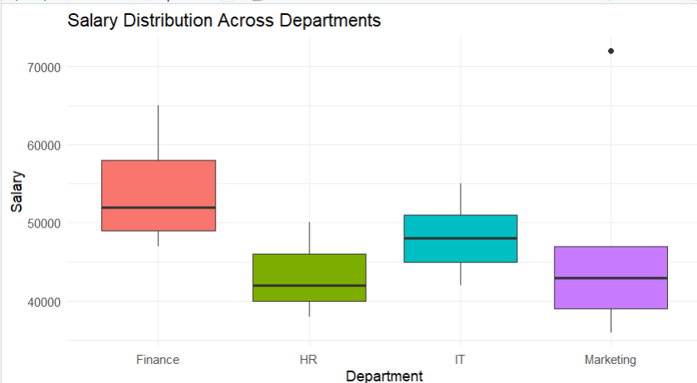
- Identify any possible skewness or unusual observations and explain what the plots reveal.
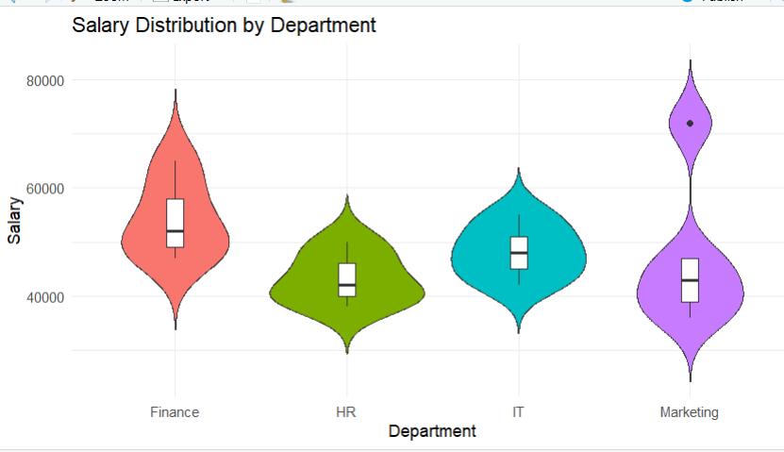

Question 2 – Visualizing Many Distributions Using Bean Plots
Dataset: Student_Performance.csv
Assessment Task
Using the Student_Performance dataset, investigate how scores are distributed across courses.
1. Visualize the score distribution for all four courses at the same time.
2. Create bean plots (or an equivalent violin/density-based visualization if a bean-plot package is unavailable). 3. Create a second visualization with the distributions arranged along the vertical axis.
4. Compare the center, spread, and shape of the distributions and determine which course has the highest and most consistent performance.
Dataset:
Student_ID | Course | Study_Hours | Score
S001 | Python | 5 | 62
S002 | Python | 7 | 68
S003 | Python | 9 | 74
S004 | Python | 11 | 81
S005 | Python | 14 | 88
S006 | Statistics | 4 | 58
S007 | Statistics | 6 | 64
S008 | Statistics | 8 | 71
S009 | Statistics | 10 | 79
S010 | Statistics | 13 | 86
S011 | DataViz | 3 | 55
S012 | DataViz | 5 | 61
S013 | DataViz | 7 | 69
S014 | DataViz | 9 | 77
S015 | DataViz | 12 | 84
S016 | MachineLearning | 6 | 65
S017 | MachineLearning | 8 | 72
S018 | MachineLearning | 10 | 78
S019 | MachineLearning | 13 | 87
S020 | MachineLearning | 16 | 93

R Code:
# ============================================================
# Q2: STUDENT PERFORMANCE DISTRIBUTION
# ============================================================
library(ggplot2)
library(dplyr)
# -------------------------
# 1. Create Dataset
# -------------------------
student <- data.frame(
Student_ID = paste0("S", sprintf("%03d", 1:20)),
Course = c(
rep("Python",5),
rep("Statistics",5),
rep("DataViz",5),
rep("MachineLearning",5)
),
Study_Hours = c(
5,7,9,11,14,
4,6,8,10,13,
3,5,7,9,12,
6,8,10,13,16
),
Score = c(
62,68,74,81,88,
58,64,71,79,86,
55,61,69,77,84,
65,72,78,87,93
)
)
print(student)
# -------------------------
# 2. Horizontal Violin Plot
# -------------------------
ggplot(student, aes(x = Course, y = Score, fill = Course)) +
geom_violin(trim = FALSE) +
geom_boxplot(width = 0.12, fill = "white") +
labs(
title = "Score Distribution Across Courses",
x = "Course",
y = "Score"
) +
theme_minimal() +
theme(legend.position = "none")
# -------------------------
# 3. Vertical-axis Distribution
# -------------------------
ggplot(student, aes(x = Score, y = Course, fill = Course)) +
geom_violin(trim = FALSE) +
geom_boxplot(
width = 0.12,
orientation = "y",
fill = "white"
) +
labs(
title = "Course Score Distributions Along Vertical Axis",
x = "Score",
y = "Course"
) +
theme_minimal() +
theme(legend.position = "none")
# -------------------------
# 4. Density Plot
# -------------------------
ggplot(student, aes(x = Score, fill = Course)) +
geom_density(alpha = 0.4) +
labs(
title = "Density Distribution of Student Scores",
x = "Score",
y = "Density"
) +
theme_minimal()
# -------------------------
# 5. Summary Statistics
# -------------------------
student_summary <- student %>%
group_by(Course) %>%
summarise(
Mean = mean(Score),
Median = median(Score),
SD = sd(Score),
Minimum = min(Score),
Maximum = max(Score),
Range = max(Score) - min(Score)
)
print(student_summary)
Answers:
- Visualize the score distribution for all four courses at the same time.
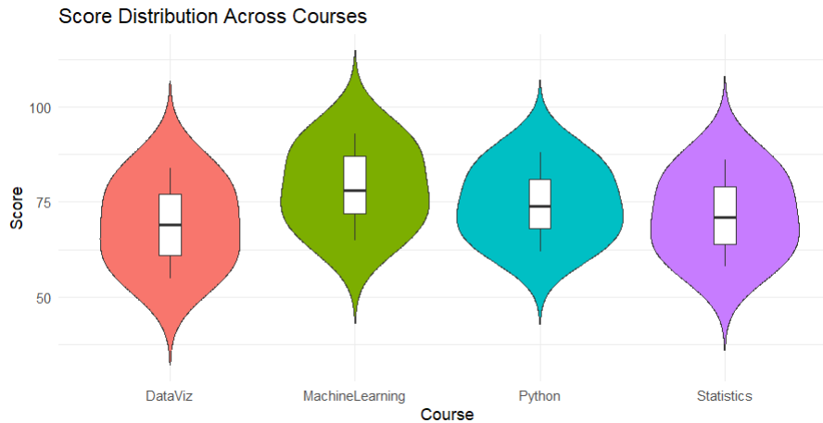
- Create bean plots (or an equivalent violin/density-based visualization if a bean-plot package is unavailable).
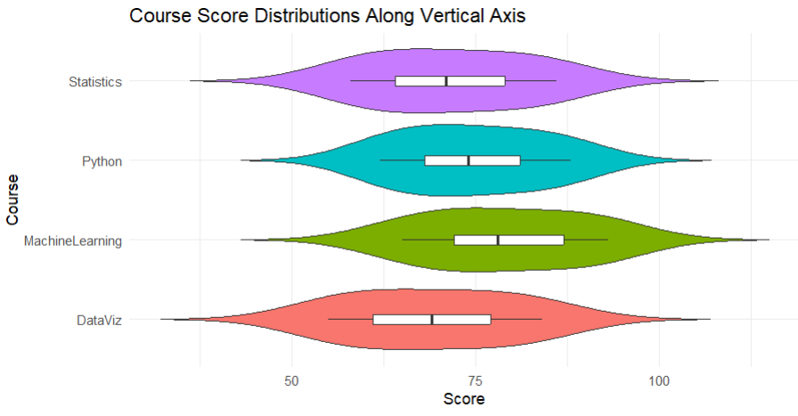
- Create a second visualization with the distributions arranged along the vertical axis.
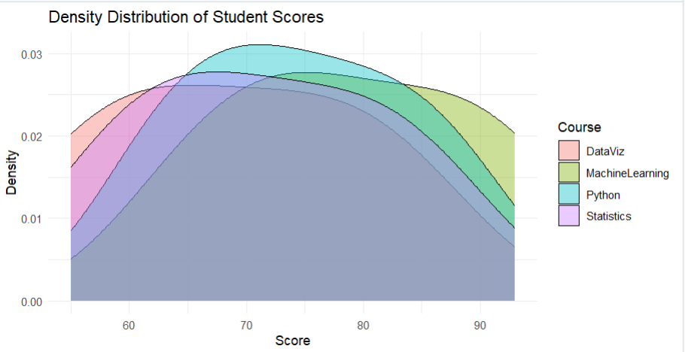
- Compare the center, spread, and shape of the distributions and determine which course has the highest and most consistent performance.
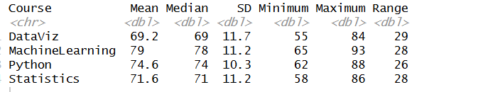
Question 3 – Comparing Proportions with Pie, Side-by-Side and Stacked Bars Dataset: Customer_Purchases.csv
Assessment Task
Using the Customer_Purchases dataset, analyze purchase proportions.
1. Create a pie chart showing the overall proportion of purchases by Product.
2. Create side-by-side bar charts comparing Product counts across Regions.
3. Create a stacked bar chart showing product composition within each Region.
4. Convert the stacked chart into a 100% stacked bar chart and compare proportions rather than raw counts.
5. Explain why one of these visualizations may be more appropriate than another for comparing regional proportions.
Dataset:
Customer_ID | Region | Product | Purchase_Type | Count
C001 | North | Laptop | Online | 25
C002 | North | Phone | Online | 35
C003 | North | Tablet | Store | 20
C004 | South | Laptop | Store | 30
C005 | South | Phone | Online | 40
C006 | South | Tablet | Store | 25
C007 | East | Laptop | Online | 28
C008 | East | Phone | Store | 32
C009 | East | Tablet | Online | 18
C010 | West | Laptop | Store | 22
C011 | West | Phone | Online | 38
C012 | West | Tablet | Store | 27

R Code:
# ============================================================
# Q3: CUSTOMER PURCHASE ANALYSIS
# ============================================================

library(ggplot2)
library(dplyr)

# -------------------------
# 1. Create Dataset
# -------------------------

customer <- data.frame(
Customer_ID = paste0("C", sprintf("%03d", 1:12)),

Region = c(
"North","North","North",
"South","South","South",
"East","East","East",
"West","West","West"
),

Product = c(
"Laptop","Phone","Tablet",
"Laptop","Phone","Tablet",
"Laptop","Phone","Tablet",
"Laptop","Phone","Tablet"
),

Purchase_Type = c(
"Online","Online","Store",
"Store","Online","Store",
"Online","Store","Online",
"Store","Online","Store"
),

Count = c(
25,35,20,
30,40,25,
28,32,18,
22,38,27
)
)

print(customer)

# -------------------------
# 2. Overall Product Pie Chart
# -------------------------

product_total <- customer %>%
group_by(Product) %>%
summarise(Total = sum(Count))

ggplot(product_total, aes(x = "", y = Total, fill = Product)) +
geom_bar(stat = "identity", width = 1) +
coord_polar("y") +
labs(
title = "Overall Purchase Proportion by Product",
fill = "Product"
) +
theme_void()

# -------------------------
# 3. Side-by-Side Bar Chart
# -------------------------

ggplot(customer,
aes(x = Region, y = Count, fill = Product)) +
geom_col(position = "dodge") +
labs(
title = "Product Counts Across Regions",
x = "Region",
y = "Purchase Count",
fill = "Product"
) +
theme_minimal()

# -------------------------
# 4. Stacked Bar Chart
# -------------------------

ggplot(customer,
aes(x = Region, y = Count, fill = Product)) +
geom_col() +
labs(
title = "Stacked Product Composition by Region",
x = "Region",
y = "Purchase Count",
fill = "Product"
) +
theme_minimal()

# -------------------------
# 5. 100% Stacked Bar Chart
# -------------------------

ggplot(customer,
aes(x = Region, y = Count, fill = Product)) +
geom_col(position = "fill") +
scale_y_continuous(labels = scales::percent) +
labs(
title = "100% Stacked Bar Chart of Regional Product Proportions",
x = "Region",
y = "Percentage",
fill = "Product"
) +
theme_minimal()

# -------------------------
# 6. Regional Proportions
# -------------------------

regional <- customer %>%
group_by(Region, Product) %>%
summarise(Count = sum(Count), .groups = "drop") %>%
group_by(Region) %>%
mutate(Proportion = Count / sum(Count))

print(regional)

Answers:
- Create a pie chart showing the overall proportion of purchases by Product.
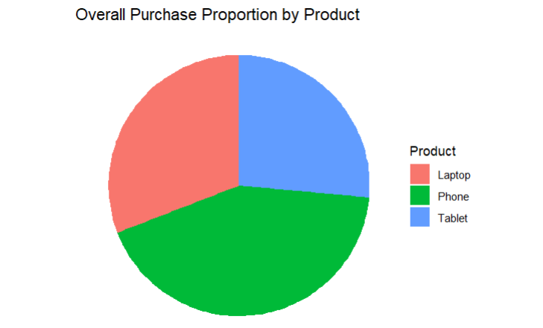
- Create side-by-side bar charts comparing Product counts across Regions.
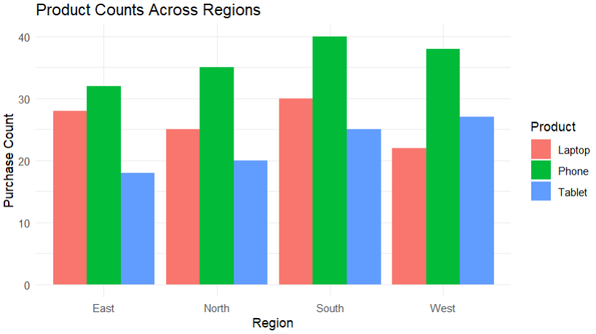
- Create a stacked bar chart showing product composition within each Region.
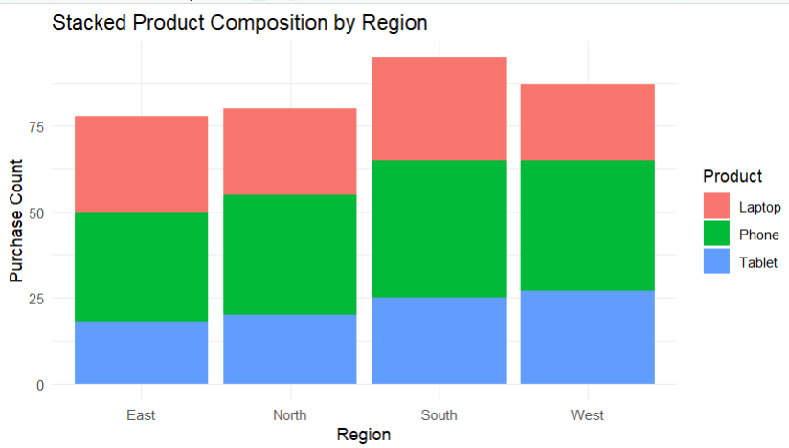
- Convert the stacked chart into a 100% stacked bar chart and compare proportions rather than raw counts.
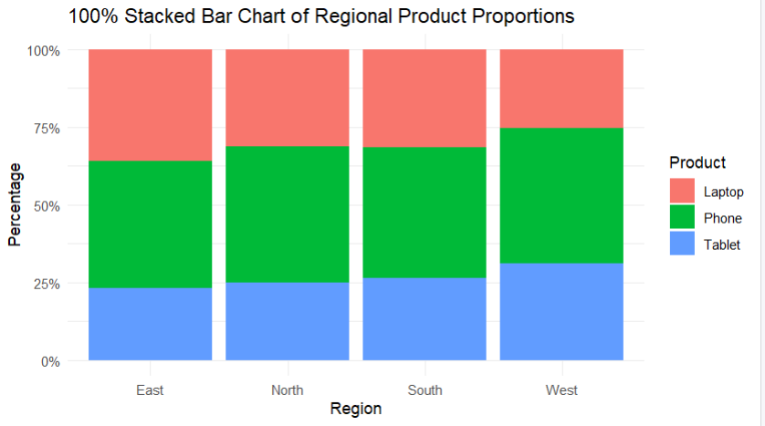
- Explain why one of these visualizations may be more appropriate than another for comparing regional proportions.
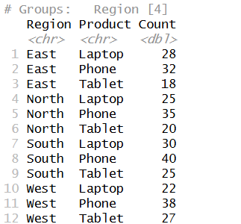

Question 4 – Nested Proportions Using Treemap and Sunburst Charts Dataset: Company_Sales.csv
Assessment Task
Using the Company_Sales dataset, visualize nested proportions in the sales hierarchy.
1. Create a treemap showing Region → Category → Subcategory, with rectangle size representing Sales.
2. Create a sunburst chart representing the same hierarchy.
3. Identify the largest region, category, and subcategory by sales.
4. Compare the readability of the treemap and sunburst chart for identifying nested proportions.
5. State one potential limitation of each visualization.
Dataset:
Region | Category | Subcategory | Sales
North | Electronics | Laptop | 52000
North | Electronics | Phone | 38000
North | Furniture | Chair | 22000
North | Furniture | Desk | 18000
South | Electronics | Laptop | 46000
South | Electronics | Phone | 42000
South | Furniture | Chair | 25000
South | Furniture | Desk | 21000
East | Electronics | Laptop | 58000
East | Electronics | Phone | 35000
East | Furniture | Chair | 19000
East | Furniture | Desk | 23000
West | Electronics | Laptop | 49000
West | Electronics | Phone | 44000
West | Furniture | Chair | 27000
West | Furniture | Desk | 20000

R Code:
# ============================================================
# Q4: COMPANY SALES HIERARCHY
# ============================================================

library(ggplot2)
library(dplyr)
library(treemapify)
library(plotly)

# -------------------------
# 1. Create Dataset
# -------------------------

sales <- data.frame(
Region = c(
rep("North",4),
rep("South",4),
rep("East",4),
rep("West",4)
),

Category = rep(
c(
"Electronics","Electronics",
"Furniture","Furniture"
), 4
),

Subcategory = rep(
c("Laptop","Phone","Chair","Desk"), 4
),

Sales = c(
52000,38000,22000,18000,
46000,42000,25000,21000,
58000,35000,19000,23000,
49000,44000,27000,20000
)
)

print(sales)

# -------------------------
# 2. Treemap
# -------------------------

ggplot(
sales,
aes(
area = Sales,
fill = Category,
label = paste(Subcategory, "\n", Sales)
)
) +
geom_treemap() +
geom_treemap_text(
colour = "white",
place = "centre",
grow = TRUE
) +
labs(
title = "Company Sales Treemap",
fill = "Category"
) +
theme_minimal()

# -------------------------
# 3. Treemap by Region
# -------------------------

ggplot(
sales,
aes(
area = Sales,
fill = Category,
subgroup = Region,
label = Subcategory
)
) +
geom_treemap() +
geom_treemap_subgroup_border() +
geom_treemap_text(colour = "white") +
labs(
title = "Region → Category → Subcategory Sales Treemap"
) +
theme_minimal()

# -------------------------
# 4. Sunburst Chart
# -------------------------

sunburst <- plot_ly(
sales,
type = "sunburst",
labels = ~Subcategory,
parents = ~Category,
values = ~Sales,
branchvalues = "total"
)

sunburst <- sunburst %>%
layout(
title = "Company Sales Sunburst Chart"
)

sunburst

# -------------------------
# 5. Summary
# -------------------------

region_summary <- sales %>%
group_by(Region) %>%
summarise(Total_Sales = sum(Sales)) %>%
arrange(desc(Total_Sales))

category_summary <- sales %>%
group_by(Category) %>%
summarise(Total_Sales = sum(Sales)) %>%
arrange(desc(Total_Sales))

subcategory_summary <- sales %>%
group_by(Subcategory) %>%
summarise(Total_Sales = sum(Sales)) %>%
arrange(desc(Total_Sales))

print(region_summary)
print(category_summary)
print(subcategory_summary)
Answers:
- Create a treemap showing Region → Category → Subcategory, with rectangle size representing Sales.
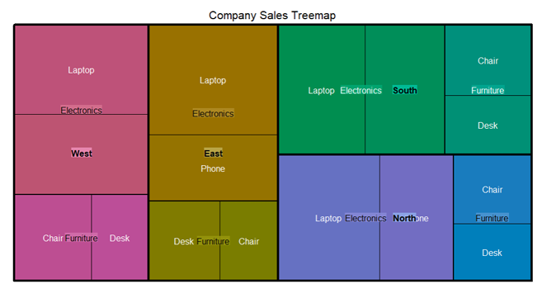
- Create a sunburst chart representing the same hierarchy.
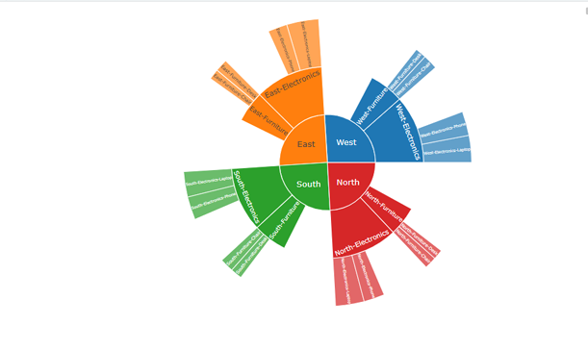

- Identify the largest region, category, and subcategory by sales.
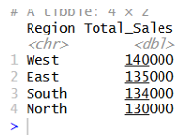
- Compare the readability of the treemap and sunburst chart for identifying nested proportions.
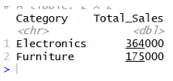
5. State one potential limitation of each visualization.
- A major limitation of both treemap and sunburst visualizations is difficulty in making precise visual comparisons of sizes or proportions.
- Because human eyes struggle to accurately judge relative differences in irregular areas (rectangles in treemaps) or arc lengths/angles (segments in sunbursts) compared to a linear baseline, it is hard to tell which data categories are truly larger or by how much.

Question 5 – Flow-Based Proportions with Sankey Diagram and Parallel Sets Dataset: Student_Career_Path.csv
Assessment Task
Using the Student_Career_Path dataset, analyze how students flow from specialization to internship status and placement sector.
1. Create a Sankey diagram showing Specialization → Internship → Placement_Sector, with flow width based on Students.
2. Create a parallel sets visualization for the same categorical relationships.
3. Identify the major flows and compare the placement patterns of students with and without internships.
4. Explain which visualization communicates the flow structure more clearly and why.
5. Discuss one way the chart could become misleading if proportions are represented using inappropriate scales, colors, or labels.
Dataset:
Student_Group | Specialization | Internship | Placement_Sector | Students
G1 | Data Analytics | Yes | IT | 18
G2 | Data Analytics | Yes | Finance | 12
G3 | Data Analytics | No | IT | 8
G4 | AI | Yes | IT | 20
G5 | AI | Yes | Healthcare | 10
G6 | AI | No | IT | 6
G7 | Cyber Security | Yes | IT | 16
G8 | Cyber Security | Yes | Finance | 9
G9 | Cyber Security | No | Government | 7
G10 | Cloud Computing | Yes | IT | 15
G11 | Cloud Computing | Yes | Finance | 8
G12 | Cloud Computing | No | Government | 5

R Code:
# ============================================================
# Q5 - SANKEY + PARALLEL SETS
# ============================================================

library(networkD3)
library(ggplot2)
library(dplyr)
library(ggalluvial)

# ============================================================
# 1. DATASET
# ============================================================

career <- data.frame(
Student_Group = c(
"G1","G2","G3","G4","G5","G6",
"G7","G8","G9","G10","G11","G12"
),

Specialization = c(
"Data Analytics","Data Analytics","Data Analytics",
"AI","AI","AI",
"Cyber Security","Cyber Security","Cyber Security",
"Cloud Computing","Cloud Computing","Cloud Computing"
),

Internship = c(
"Yes","Yes","No",
"Yes","Yes","No",
"Yes","Yes","No",
"Yes","Yes","No"
),

Placement_Sector = c(
"IT","Finance","IT",
"IT","Healthcare","IT",
"IT","Finance","Government",
"IT","Finance","Government"
),

Students = c(
18,12,8,
20,10,6,
16,9,7,
15,8,5
)
)

print(career)

# ============================================================
# 2. SANKEY DIAGRAM
# ============================================================

nodes <- data.frame(
name = unique(c(
career$Specialization,
career$Internship,
career$Placement_Sector
))
)

flow1 <- career %>%
group_by(Specialization, Internship) %>%
summarise(
Students = sum(Students),
.groups = "drop"
) %>%
rename(
source = Specialization,
target = Internship
)

flow2 <- career %>%
group_by(Internship, Placement_Sector) %>%
summarise(
Students = sum(Students),
.groups = "drop"
) %>%
rename(
source = Internship,
target = Placement_Sector
)

links_data <- bind_rows(flow1, flow2)

links <- links_data %>%
mutate(
source = match(source, nodes$name) - 1,
target = match(target, nodes$name) - 1,
value = Students
)

sankey <- sankeyNetwork(
Links = as.data.frame(links),
Nodes = as.data.frame(nodes),
Source = "source",
Target = "target",
Value = "value",
NodeID = "name",
fontSize = 13,
nodeWidth = 30,
sinksRight = TRUE
)

# Show Sankey
sankey

# ============================================================
# 3. PARALLEL SETS
# ============================================================

parallel_plot <- ggplot(
career,
aes(
axis1 = Specialization,
axis2 = Internship,
axis3 = Placement_Sector,
y = Students
)
) +
geom_alluvium(
aes(fill = Internship),
width = 1/12,
alpha = 0.7
) +
geom_stratum(
width = 1/12,
fill = "grey80",
colour = "black"
) +
geom_text(
stat = "stratum",
aes(label = after_stat(stratum)),
size = 3
) +
scale_x_discrete(
limits = c(
"Specialization",
"Internship",
"Placement Sector"
),
expand = c(0.05, 0.05)
) +
labs(
title = "Parallel Sets - Student Career Path",
subtitle = "Specialization → Internship → Placement Sector",
x = NULL,
y = "Number of Students",
fill = "Internship"
) +
theme_minimal()

# IMPORTANT: Display second graph
print(parallel_plot)

# ============================================================
# 4. RESULTS
# ============================================================

cat(
"\nStudents with Internship:",
sum(career$Students[career$Internship == "Yes"])
)

cat(
"\nStudents without Internship:",
sum(career$Students[career$Internship == "No"])
)
cat("\n")
Answers:
- Create a Sankey diagram showing Specialization → Internship → Placement_Sector, with flow width based on Students.
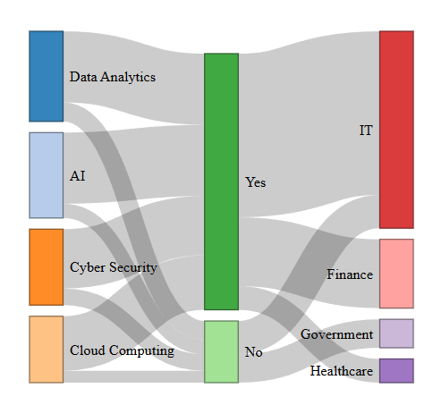
- Create a parallel sets visualization for the same categorical relationships.
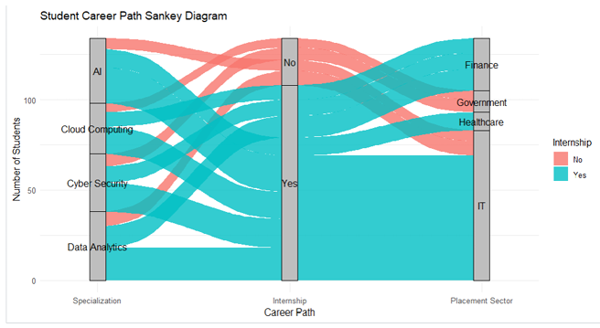
- Identify the major flows and compare the placement patterns of students with and without internships.
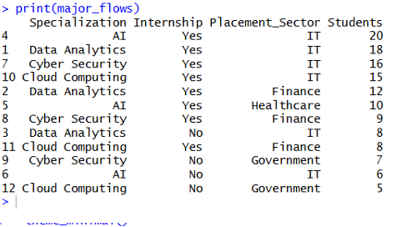
- Explain which visualization communicates the flow structure more clearly and why.
Sankey diagram
The Sankey diagram communicates the flow structure more clearly.
It makes it easy to follow: Specialization → Internship → Placement Sector The width of each connection immediately shows how many students follow that path.

Parallel Sets
The parallel-sets chart is also useful, especially for comparing multiple categorical dimensions simultaneously, but the crossing lines can become harder to follow when there are many categories.
Therefore: Sankey diagram is better for understanding the overall flow of students through the career pathway.
5. Discuss one way the chart could become misleading if proportions are represented using inappropriate scales, colors, or labels.
- The chart can become misleading if the flow widths, colors, or labels do not accurately represent the proportions.
- For example, if a flow representing 5 students is displayed almost as wide as a flow representing 20 students, the viewer may incorrectly assume that both flows have similar importance.
- Similarly, using confusing colors or misleading percentage labels can make the comparison between internship and non-internship students difficult.

Expected Student Deliverables
• R script (.R) containing data creation/import, data preparation, analysis, and visualization code. • All required plots with meaningful titles, axis labels, legends, and appropriate scales. • A short interpretation for each visualization.
• A brief comparison of alternative visualization methods where requested.
• A concluding statement identifying important patterns, differences, or potential misleading visual encodings.
Suggested Assessment Criteria
Criterion | Weight
Dataset preparation | 20%
Correct R programming and use of visualization packages | 25%
Appropriate choice and construction of visualizations | 25%
Interpretation and analytical reasoning | 20%

Clarity, labeling, and presentation | 10%

